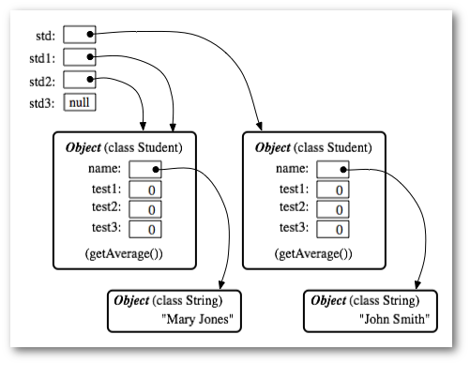

Objects are things in memory while instances are things that reference to them. In the above pic:

* std(instance) -> Student Object (right)
* std1(instance) -> Student Object (left)
* std2(instance) -> Student Object (left)
* std3(instance) -> no object (null)